

**Department of Computer Engineering**

**Spring 2018**

**CMPE-208: Net Architecture and Protocol**

**PROJECT OUTLINE**

**By**

**Team 4**

**Virat Mathur**

**Shivangi Gupta**

**Tejas Chumbalkar**

**Vishal Govindraddi Yarabandi**

**OBJECTIVE:**

Objective of this project is to study how the computer networking concepts are used in implementing consumer software products. This project will be focused on the study of various computer networking protocols used in the Dropbox file sharing application.

**LITERATURE:**

Dropbox is an offsite cloud based application used for file sharing and storage. This lets users to store their files securely and keep the files in sync across all the Dropbox configured devices. The main advantage of Dropbox is that, it offers a great set of storage and sharing capabilities which are free of charge for an individual user. Hosted on cloud, Dropbox doesn’t require complex set up or timely installations.

**FEATURES:**

* File Sharing and Storage
* Automatic updates
* Offline Access
* Backup and File recovery
* Device compatibility
* Security using 256 bit AES encryption
* Set Manual Bandwidth
* Link Sharing

**ARCHITECTURE:**

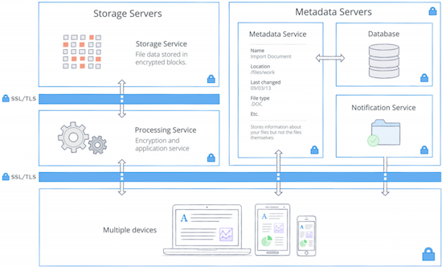

Figure 1 Dropbox Architecture

1. **Storage Service:**

The user’s files are stored in encrypted blocks using this service. Each file is split into 4MB blocks, where the last block is smaller if the file size is not divisible by four. Hash value of every block is generated using SHA-256 hashing mechanism. Each individual encrypted file block is retrieved based on its hash value and an additional layer of encryption is provided for all the file blocks at rest using strong cipher.

1. **Metadata Service:**

Metadata such as file names and types of user data are stored in a separate storage service other than file blocks. This metadata acts as index for retrieving corresponding user data. The metadata is stored in a distributed database for better performance.

1. **Processing Service:**

This service does all the necessary processing of the file data; which is dividing the file into blocks and ciphering each block before transferring to the storage service. It is also responsible for syncing only the modified file blocks into the storage instead of replacing the entire file.

1. **Notification Service:**

This is a service dedicated to monitor if changes have been made to data on the Dropbox accounts. File data or metadata is not stored or transferred in this service. Whereas Dropbox client establishes a long poll connection to this service and notify about the changes on the data.

s

**FILE SHARING MECHANISM:**

The actual block transfer is done over HTTPS. Each computer runs an HTTPS server with endpoints of the form '**/blocks/[namespace_id]/[block_hash]**'. It supports the methods GET and HEAD. HEAD is used for checking if the block exists and GET will retrieve the block. HEAD is useful in that, it allows polling multiple peers to see if they have the block and download it from only one of them.

An attacker might be able to learn something about the data by watching which block hashes are requested. The solution to this is to use SSL encryption. A pair of SSL keys/certificates are generated for every namespace. These are distributed from Dropbox servers to users’ computers which are authenticated for the namespace. These are rotated every time membership changes. It requires both ends of the HTTPS connection to authenticate with the same certificate. This proves that both ends of the connection are authenticated.

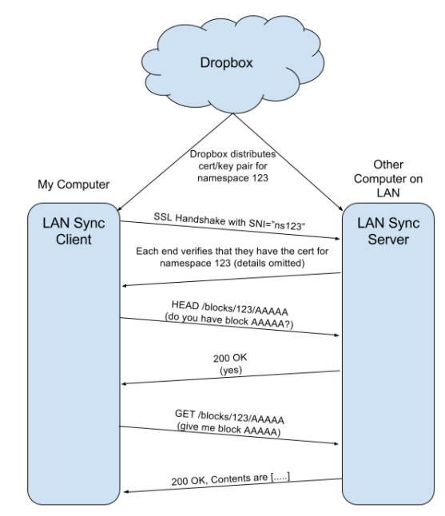

Figure 2 File Sync Mechanism

**WEEKLY PLAN:**

|  |  |
| --- | --- |
| Dates | Target |
| 03/31/2018 | Study of protocols used in the Dropbox and ways to analyze it |
| 04/06/2018 | Perform LAN Sync protocol |
| 04/13/2018 | Study the behavior using Wireshark |
| 04/20/2018 | Analyze the security protocols such as encryption and hashing functions |
| 04/27/2018 | Preparation of Project Report |
| 05/02/2018 | Preparation of Project Presentation |

**REFERENCES:**

1. <https://blogs.dropbox.com/tech/2015/10/inside-lan-sync/>
2. <https://en.wikipedia.org/wiki/Dropbox_(service)>
3. <https://www.dropbox.com/business/trust/security/architecture>
4. <https://reviews.financesonline.com/p/dropbox/>
5. <https://perso.uclouvain.be/olivier.bonaventure/blog/html/2012/09/14/understanding_the_dropbox_protocol_and_quantifying_the_usage_of_cloud_storage_services.html>